Hip Sprint Local
Webinar
Workbook

Name:…………………………………

Contact the CSP Hip Sprint Local Team: hipsprint@csp.org.uk

Hip Sprint 1 Audit

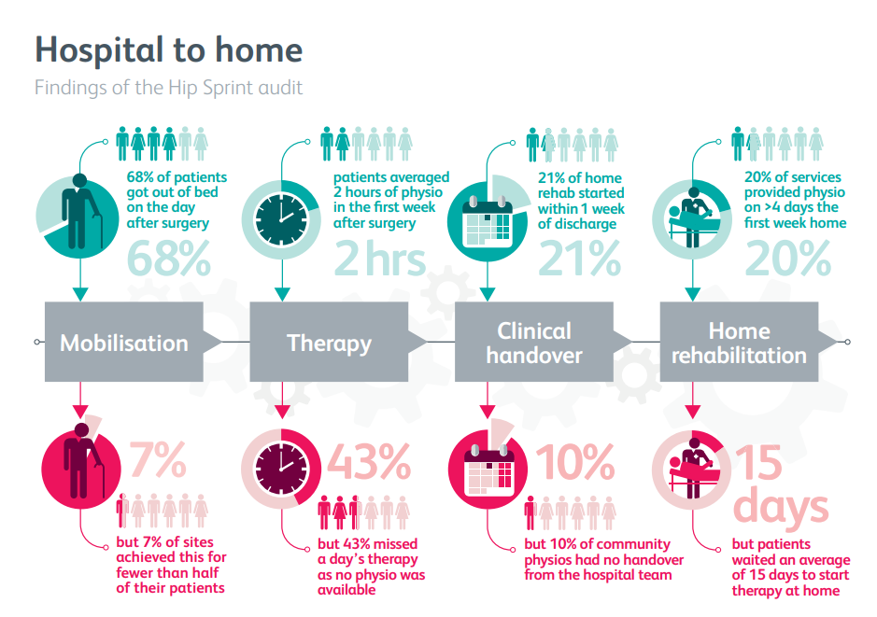

https://www.rcplondon.ac.uk/projects/physiotherapy-hip-fracture-sprint-audit-phfsa
Notes:

CSP Hip Fracture Standards

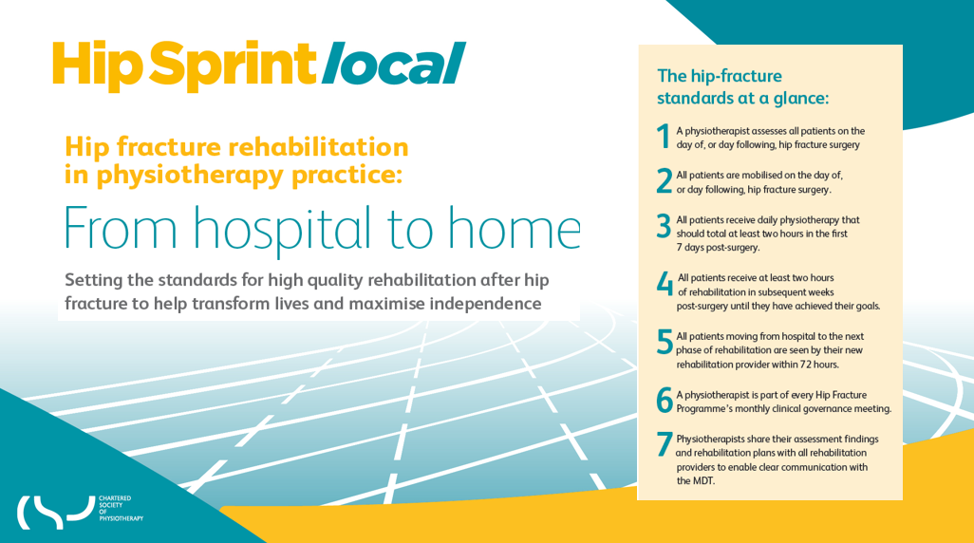

Notes:

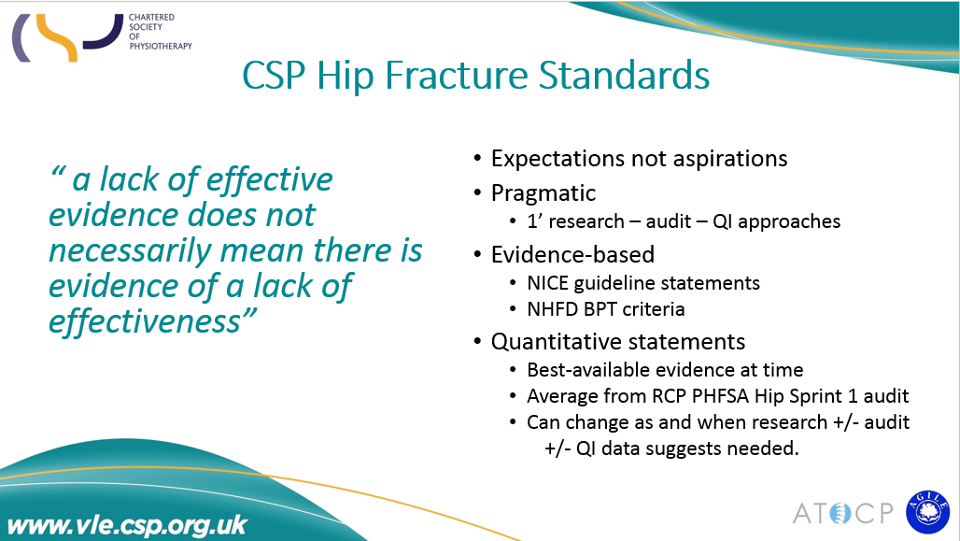

Notes:

Identifying Stakeholders

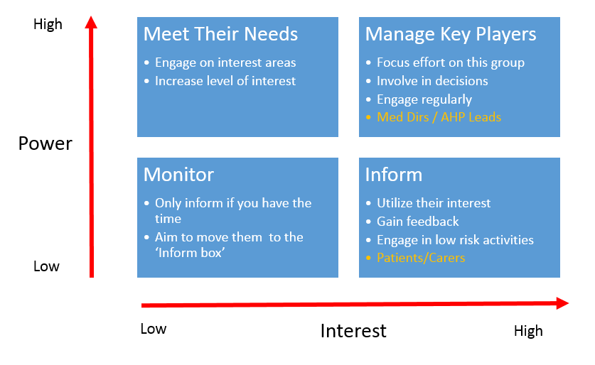

Notes:

My service stakeholders:

Notes:

Model for Improvement

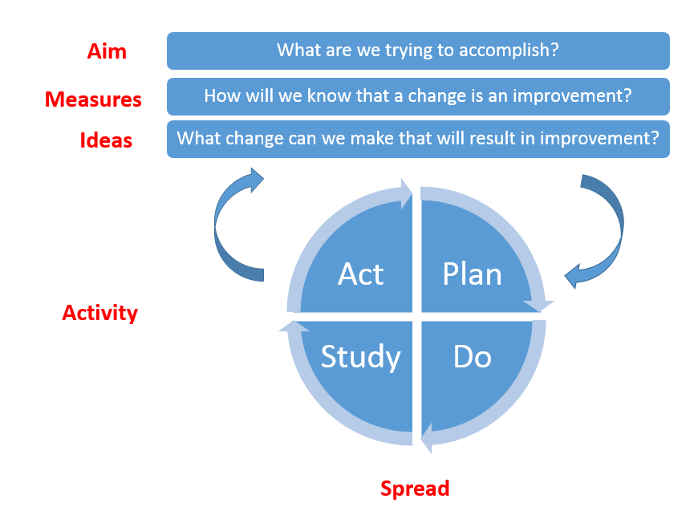

Notes:

What are we trying to accomplish?

The table below shows some examples of that you might want to achieve. You may have other ideas but try to keep them linked to the Hip Fracture Standards. This is about doing small things that could have a big impact.

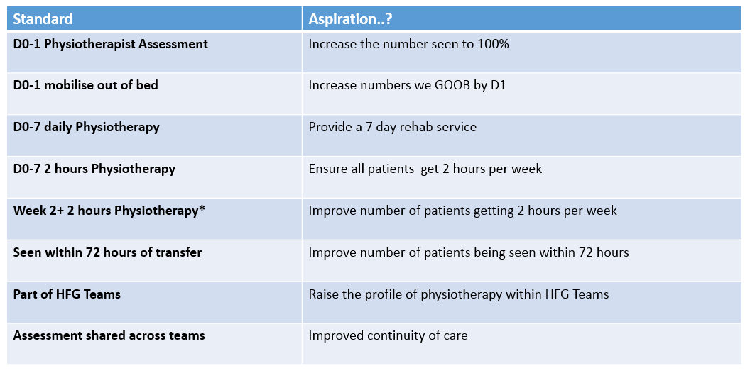

My ideas:

Standard | Aspiration?

Notes:

Creating an Aim

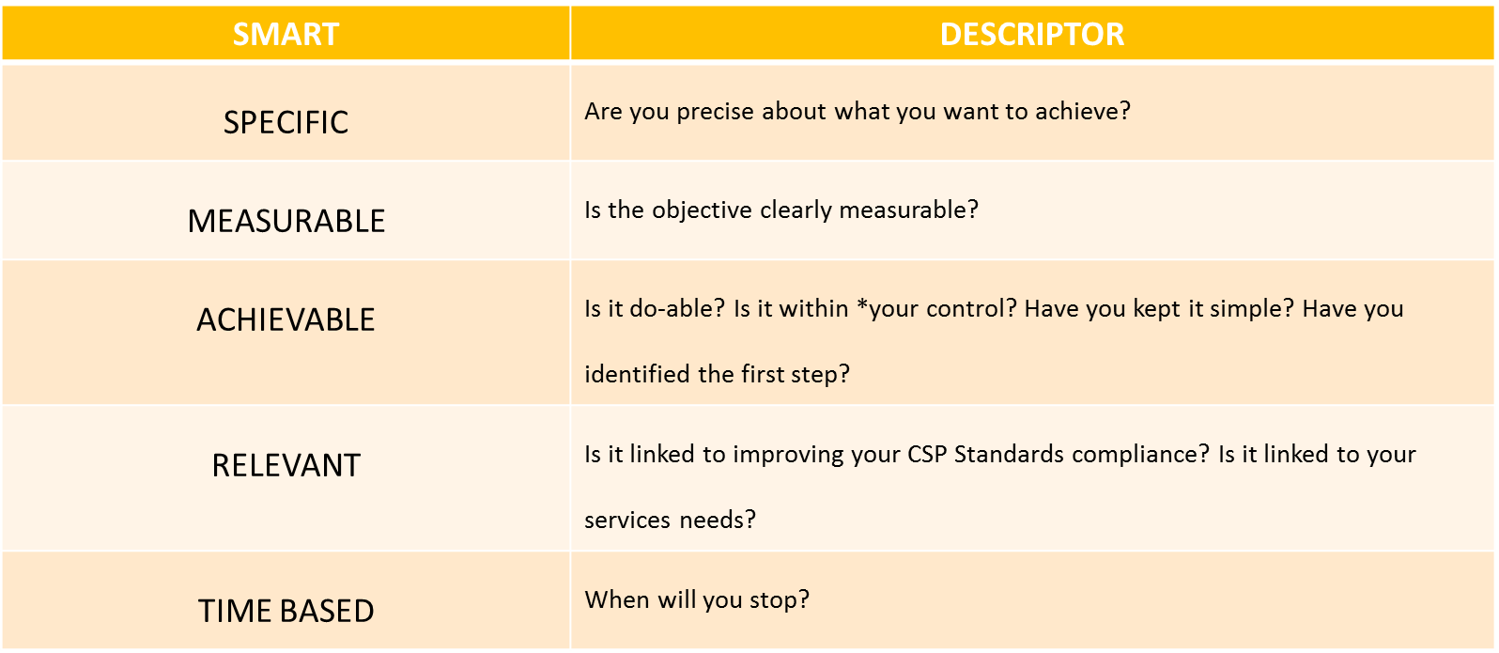

Notes:

My Aim

Worked Examples.
Here are some examples to get you thinking. You may have other ideas, remember this is about doing small things to make a big impact.
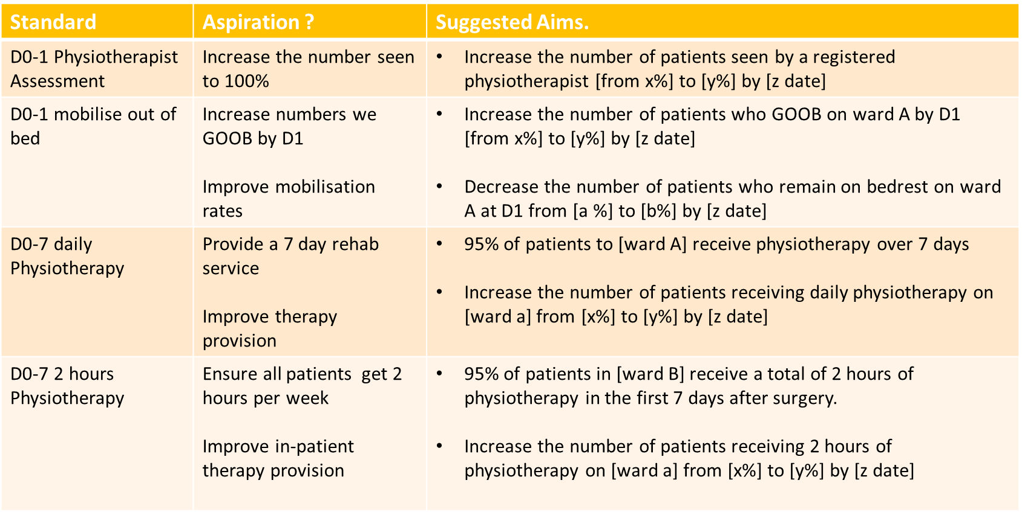

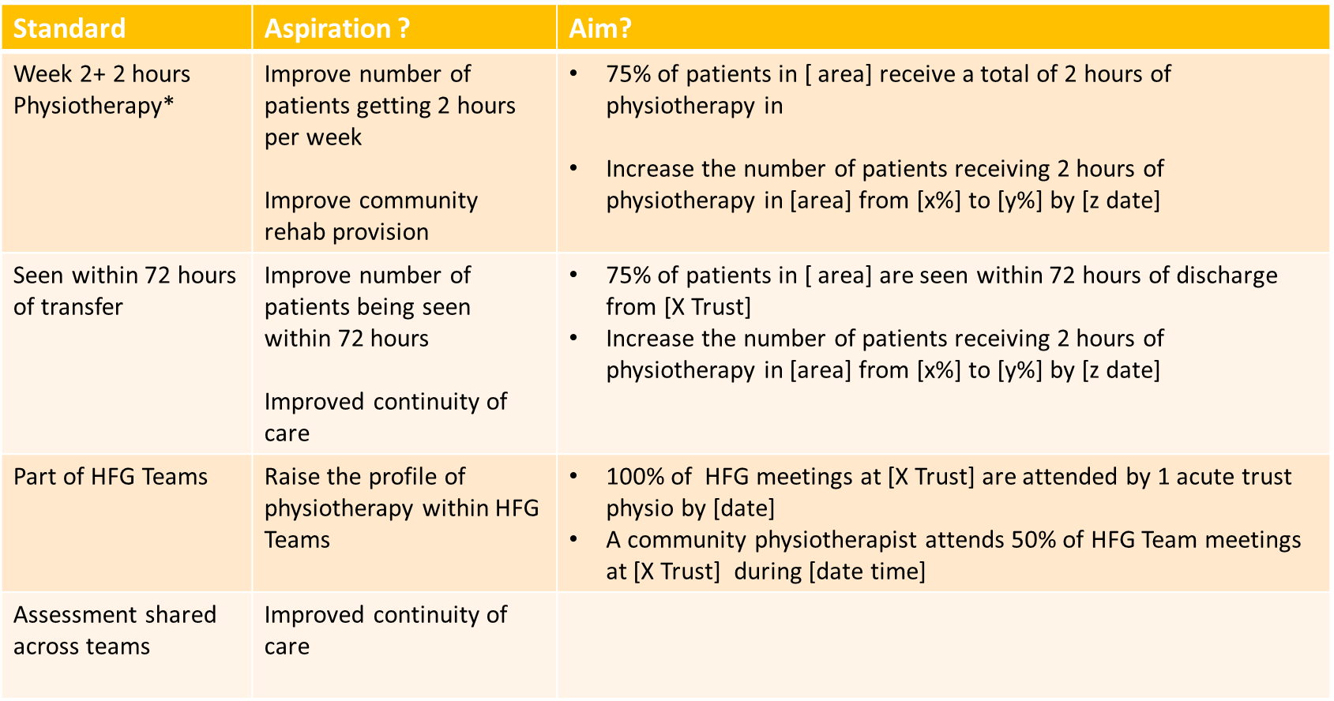

Measurement

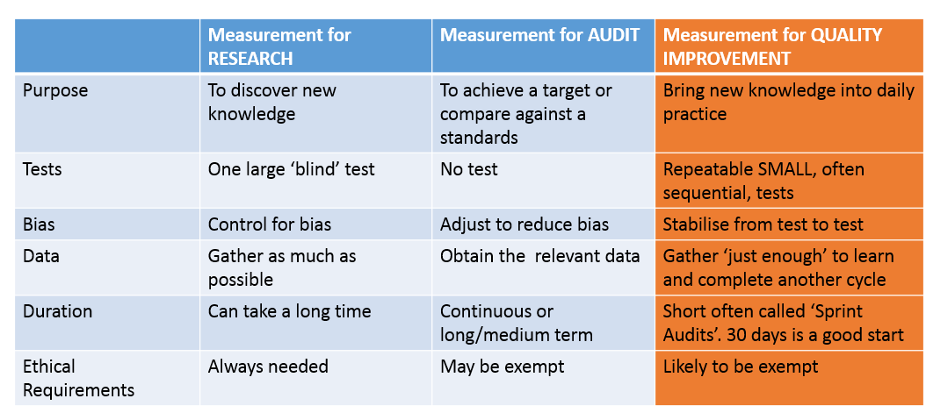

Notes:

Outcome Measures
Linked to your aim.

What are you doing? What impact has the change had on the system? What clinical impact has it had on patients, carers, other employees or other parts of the system? For example:
- Increase in income from tariff payments - ↑D0/1 assess by PT?
- Increases in % Pts discharged home?
- 120 day follow up outcomes (NHFD template)
- Standard 5 – ↓ waiting times for community physio treatment
- Other functional/clinical PROM

Use this space during the exercise:

Process Measures
How are you doing? How do you know you are doing what you should be doing? Are we heading in the right direction? How are we doing things differently? For example:
- % of Pts seen by registered PT
- % of Pts GOOB D0/D1
- Clinical hours available for clinical care
- Standard 3 - % Pts receiving physio over 7 days ( not 5)
- Standard 4 - % Pts receiving ongoing rehab ( *who have an identified need)
- Standard 6 - ? including community teams in Acute Trust work

Use this space during the exercise:

Balancing Measures
What else happened that you perhaps weren’t expecting? What has happened elsewhere in the system? Has your change had an effect elsewhere with either patients, colleagues or other services? For example:
- Decreasing LOS
- 60 day readmission rate
- 30 day mortality rates
- Team cohesions
- Pt feedback – scores
- CPD opportunities
- Profile raising
- Staffing levels ?
- Recruitment success?

Use this space during the exercise:

Notes:

PDSA Cycles

What kind of activities could I do?

.

.

.

.

.

.

.

Use the following template to write down how you will implement your change. 30 day cycles can work well. Remember you need ‘just enough’ to work out if the change is an improvement and sustainable.

PLAN
DO
STUDY
ACT

Notes:

Recording our Improvement

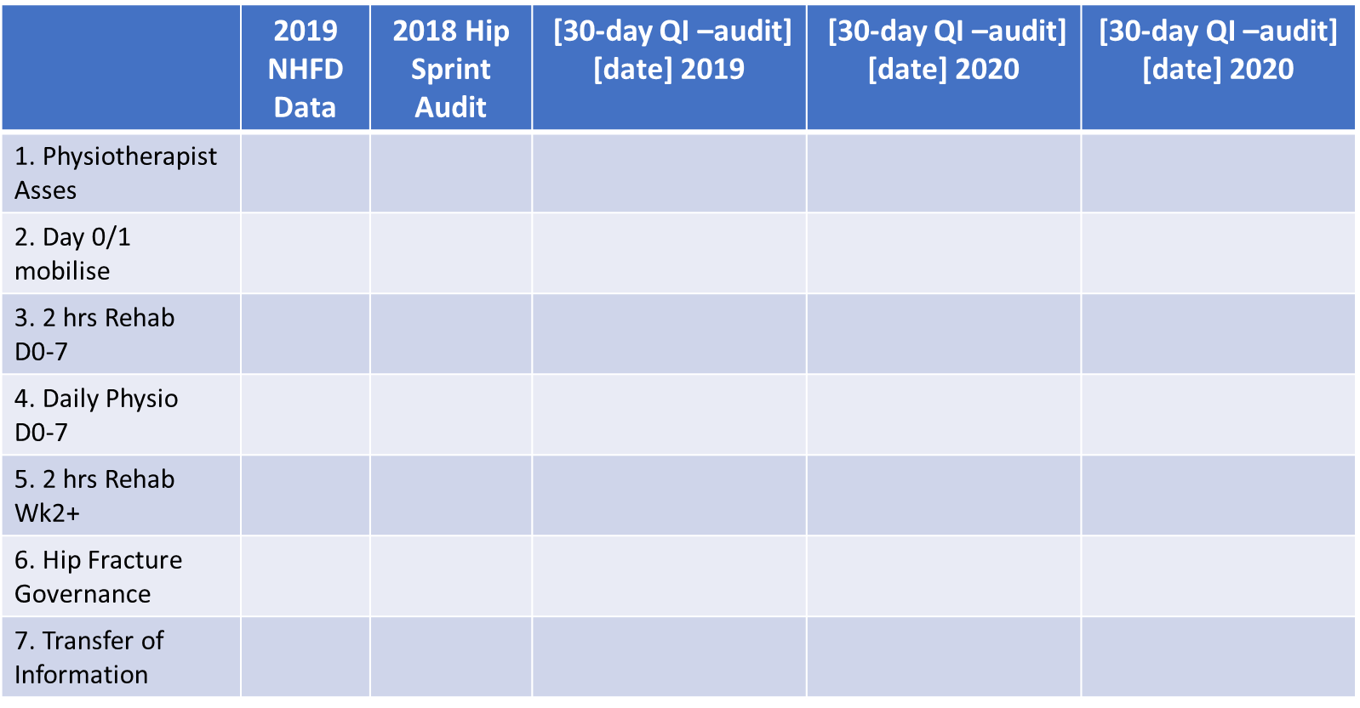

Notes:

Spreading our Improvement

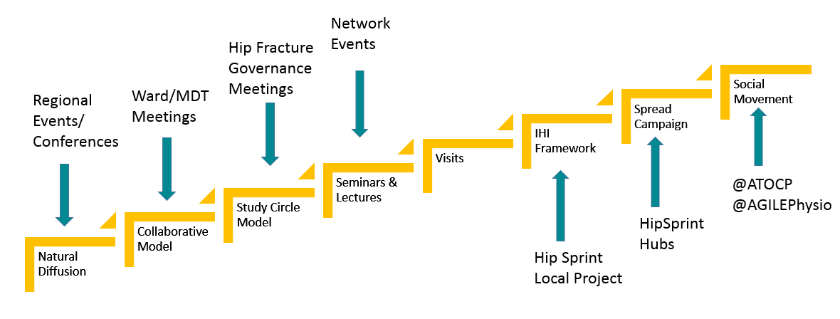

Use the templates below to help you work out what you are going to do the share your work and make continual quality improvement work become an everyday habit.

Our Spread Plan

Who is our audience? | What do we want them to think/ do? | What are we telling them? | Activities needed.
Our Team
The MDT
Managers
Patients
Commissioners
Budget Holders

What will we share?
(What have we achieved?)

Where will we share this?

When will we share this?
(Do we need to remember any early deadlines for peer-review process)

Why are we sharing this?
(What’s in it for us and others?)

Who are we sharing this with?
(Who are our audience/s?)

How are we going to share this?
(Do we need to get in touch with other people? What timescales are needed?

Where should our priorities be?
(e.g. Trust, Hubs, Network, PUK, other place?

Notes:

Action Planning

Use this space to note down what you are going to do after this events

Hip Sprint Local – Pre-Event Activity

My Local NHFD Hip Sprint Data

Acute -
- Number of cases submitted:
- Patients mobilised by the day after surgery (%):
- Average therapy received in first week after surgery (minutes):
- Average therapy received on first day post-op (weekend/weekday %):
- Patients returned to own home from Trust (%):
OR

Community -
- Number of cases submitted:
- Average days between discharge and start of therapy:
- Average number of days on which therapy recorded in first week:
- Average time receiving therapy in first week (minutes):

My 2019 NHFD Acute Trust Data

- Cases per year
- % seen by a registered physiotherapist
- % mobilised on D0/D1 after surgery
- Acute length of stay [days]

Understanding My Hip Fracture Service

Do you know how good you are?
(What is working well and why?)

Where do you sit relative to other local services?

Do you have any Hip Sprint 1 data?

Do you have any current data?
(e.g. NHFD, or NHFD-FA, Hip Sprint Local)

Where do you think your priority should be?
(e.g. mobilisation, initial therapy, handover or ongoing rehab?)

Which standard would be the most impactful for your service to start with?

Does hip fracture QI work align with organisational priorities?

Finding your PHFSA Hip Sprint audit data
- Use your mobile device and using GOOGLE CHROME (does not work with IE) log onto www.fffap.org
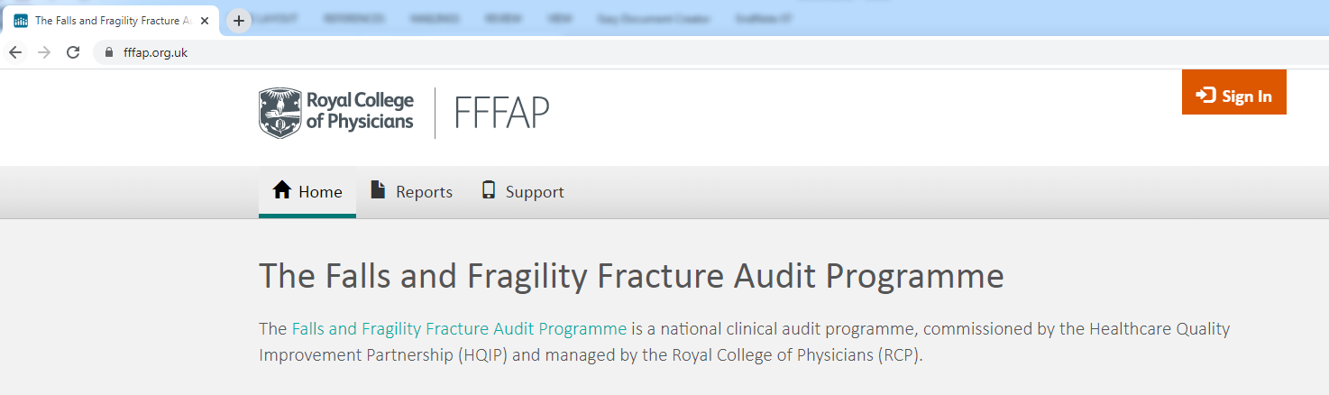
- Scroll down the page and clink on the PHFSA audit

- Click on the type of service you work in
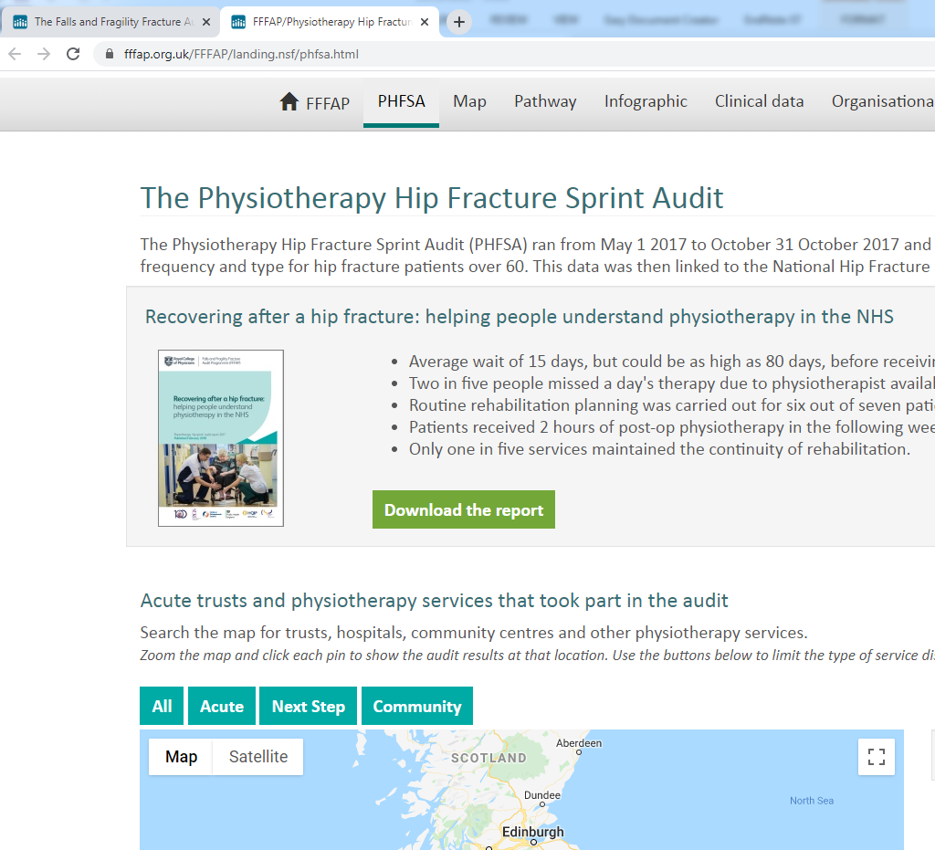

- Move around the map to find your service. Click on your pin. If your service did not take part, click on another local service. You Hip Sprint results will open up for you.
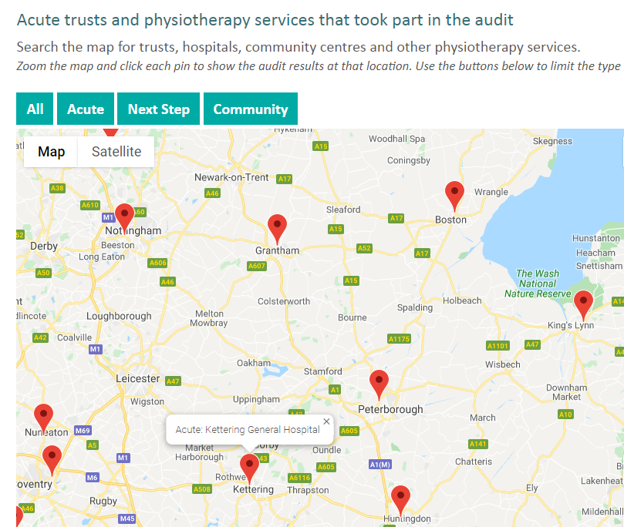

Finding your local Acute Trust data from the NHFD
- Use your mobile device to log onto www.nhfd.co.uk
- From the home screen click onto “online assessment, surgery and benchmark outcomes”
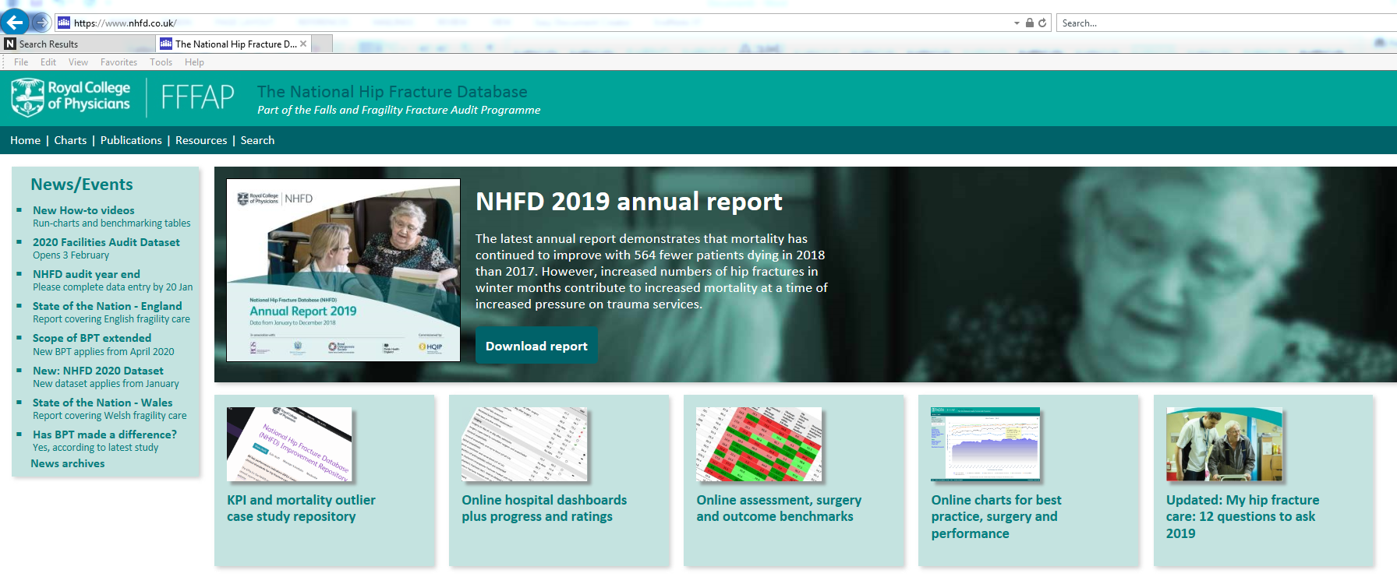

- On the left hand side of the screen select your region from the drop down choices and ‘2019’. All the regional hospitals will appear. Find your local Acute Trust. (NB: It’s helpful for Community Services to see how their linked Acute Trust performs). You will need to switch between ‘assessment’ and ‘outcome’ benchmark tables to find all the data.

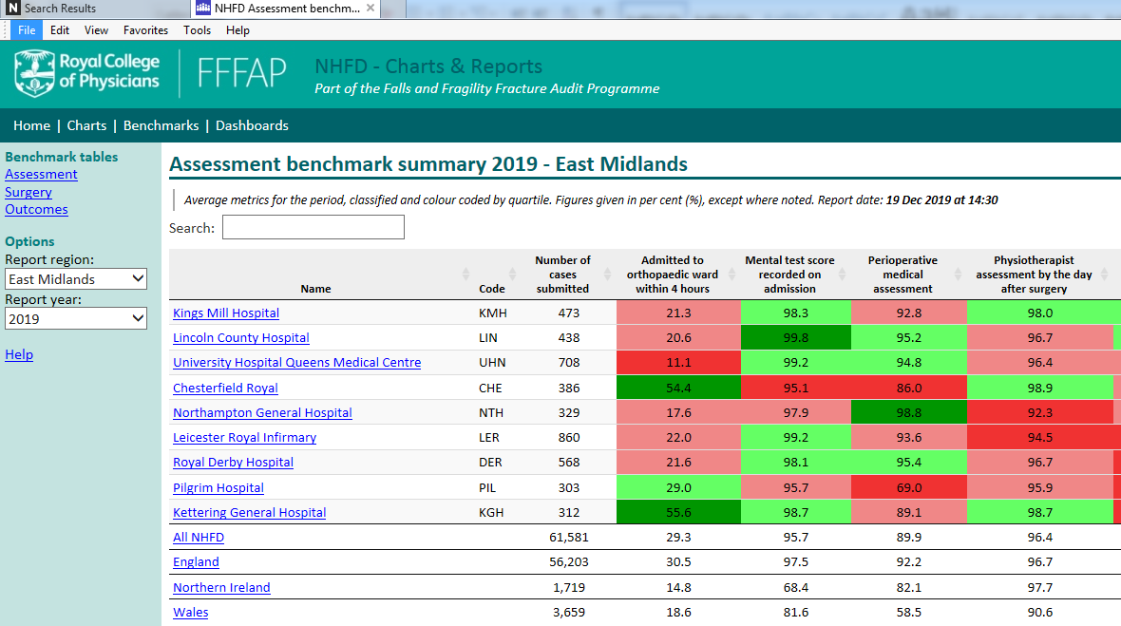

- Look at the data for your acute Trust. If you want, click on your Trust hyperlink to see more about your data:
