Use this form to help you understand the stakeholders in your service. This will help you plan your improvement activities with the CSP Hip Fracture Standards audit cycle.

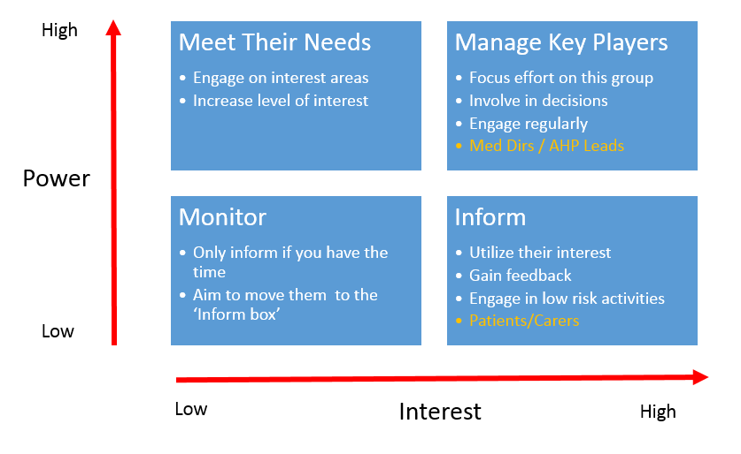
My service stakeholders:

